Fmbt Android自动化测试平台
1.程序执行图
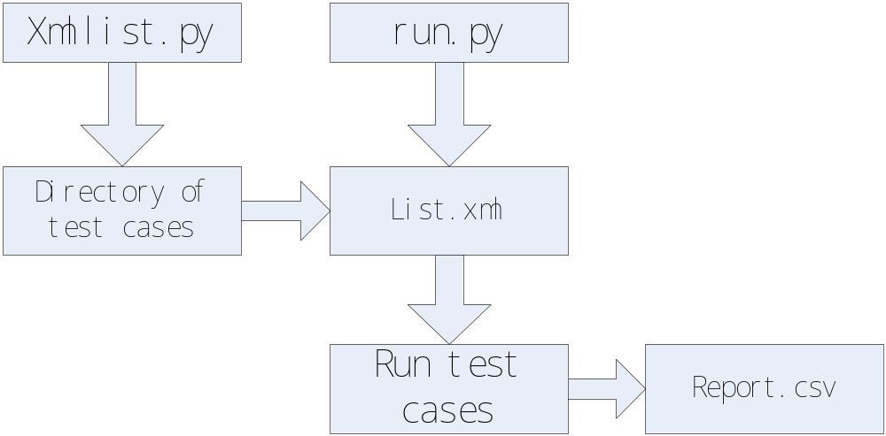
- 源代码
Xmlgenerate.py
#!/usr/bin/env python

import os,sys
import xml.dom.minidom
from xml.dom.minidom import Document

def GenerateXml(caseDir,fileName):
impl = xml.dom.minidom.getDOMImplementation()
dom = impl.createDocument(None, 'TestCases', None)
root = dom.documentElement
folders = os.listdir(caseDir)
for i in folders:
case = dom.createElement('case')
casename = dom.createTextNode(i)
case.appendChild(casename)
root.appendChild(case)

f= open('%s.xml'%fileName, 'w')
dom.writexml(f, addindent=' ', newl='\n',encoding='utf-8')
f.close()

if __name__ == '__main__':
GenerateXml(sys.argv[1],sys.argv[2])

#!/usr/bin/env python

import os,time,traceback
import csv
from xml.etree import ElementTree

def add_csv_result(FileName,CaseName,CaseResult):
f=csv.writer(file(FileName,'ab'))
f.writerow([CaseName,CaseResult])

//生成结果目录
case = []
start_time = time.strtime('%Y%m%d_%H%M%S',time.localtime(time.time()))
result_dir = "./Result"+start_time

//解析xml中的testcase
tcRoot = ElementTree("./testCases.xml")
cn = tcRoot.findall("case")
for i in cn:
cases.append(i.text)
caseList = list(set(cases))
caseList.sort(key=cases.index)
title = ['CaseNames','Verify_result']
resultcsv = result_dir+"/"+result_dir+".csv"
csv_results = open(resultcsv,"wb")
f_csv = csv.writer(csv_results)
f_csv.writerow(title)
#f_csv.close()

for caseName in caseList:
case_result_dir = result_dir+"/"+caseName
os.popen("mkdir -p %s"%(case_result_dir))
try:
os.sys.path.append("TestCases/MRD8/")
a = __import__('%s.case' %caseName)//导入caseName中模块
reload(a.case)
except ImportError, e:
print "can't find case:", caseName
continue
f = open(case_result_dir+"/"+caseName+".txt","aw")
try:
result = a.case.exe()
print result
if type(result) ==str:
add_csv_result(resultcsv,caseName,result)
except Exception, e:
print Exception, ':',e
traceback.print_exc(file=f)
f.flush()
f.close()
else:
f.writer("No expection Rise\n")
f.close()
finally:
f.close()
//导出log文件
os.popen("adb pull /mnt/sdcard/log %s/logs_adb"%(result_dir))
os.popen("adb pull /logs %s/crashLogs"%(result_dir))

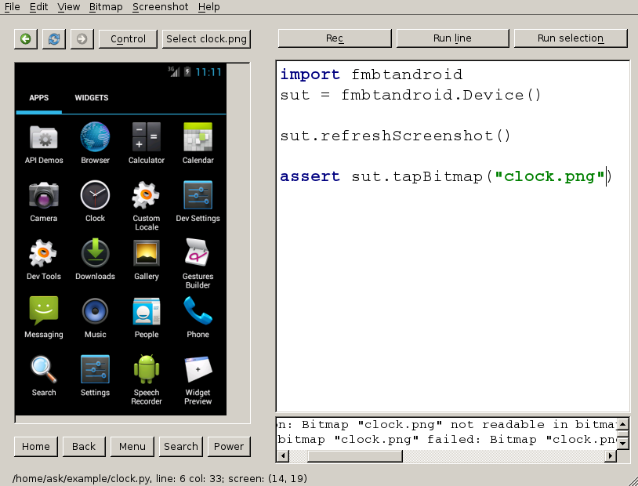
FMBT IDE界面

在票据宝app上测试到的bug
